YCDC e-Service
REGISTERATION MANUAL

FOR Licensed Contractor / Licensed Pile Companies/ Licensed Soil Investigation Companies/ Building Surveyor

https://ybps.ycdc.gov.mm/



1. Introduction
The system is built to support the following functions specific to the administration of development proposals:
- Registration of Licensed Contractor / Licensed Pile Companies/ Licensed Soil Investigation Companies/ Building Surveyor can register themselves into the system and vetting is done by the appropriate institution in order to permit them to access the system’s functionality.
- Monitoring of submitted Development proposals – Applicants can log into the system and make the extension of their licenses and new licenses. The system also notifies the Applicants/Owners/Developers via SMS and email once the proposals complete key milestones in the system. Notifications are also received when actions are pending for the applicant e.g. requests to make payment.

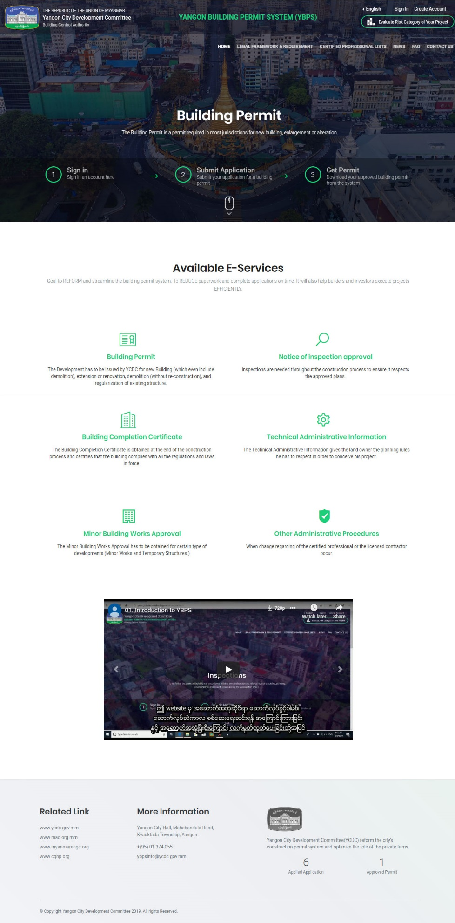

2. Registering for an Account
Registered Architects, Civil Engineer & Land Owner are allowed to register and submit development proposals on e-Service.
To register for an account, click on Create Account button at the top right corner of the website. A form to fill out account details will be shown as below. For Example
- Full Name as User’s Name
- User Name as User’s Name
- Email and Confirmed Email as User’s email address
- Password as you like (Minimum of 6 characters)
- Mobile Number as User’s mobile number
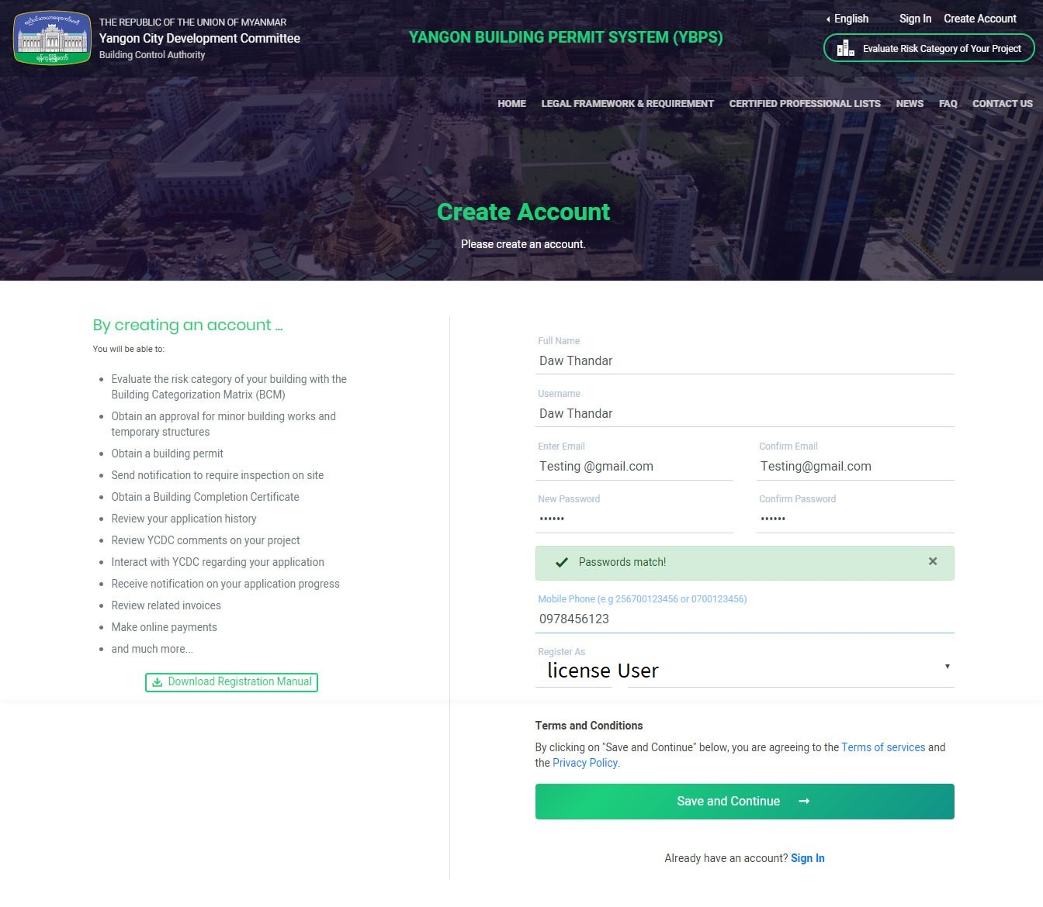
- Choose Register type from given rolls (License User). After fill out, click Save and Continue button.

A confirmation mail to activate your account will be sent to the email address that you provided in this registration form. You will success registering by clicking the link from email that you received.

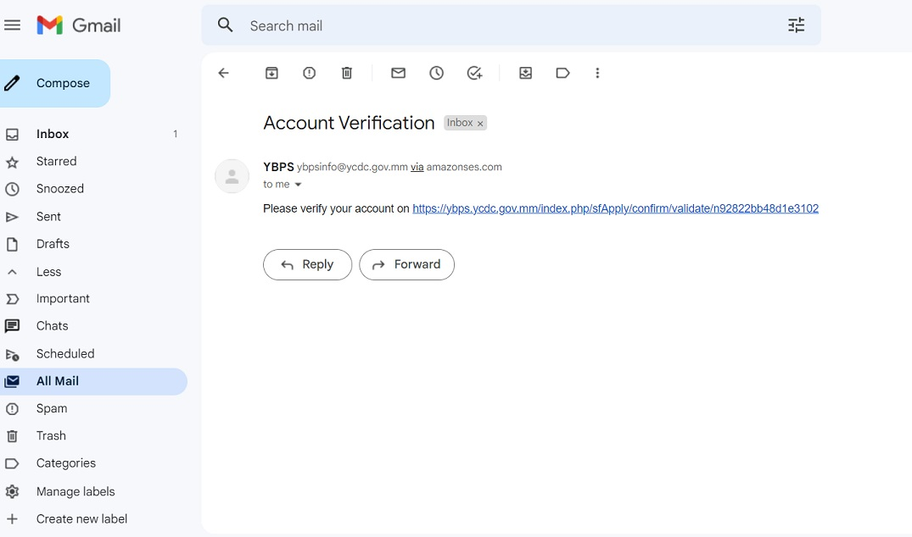

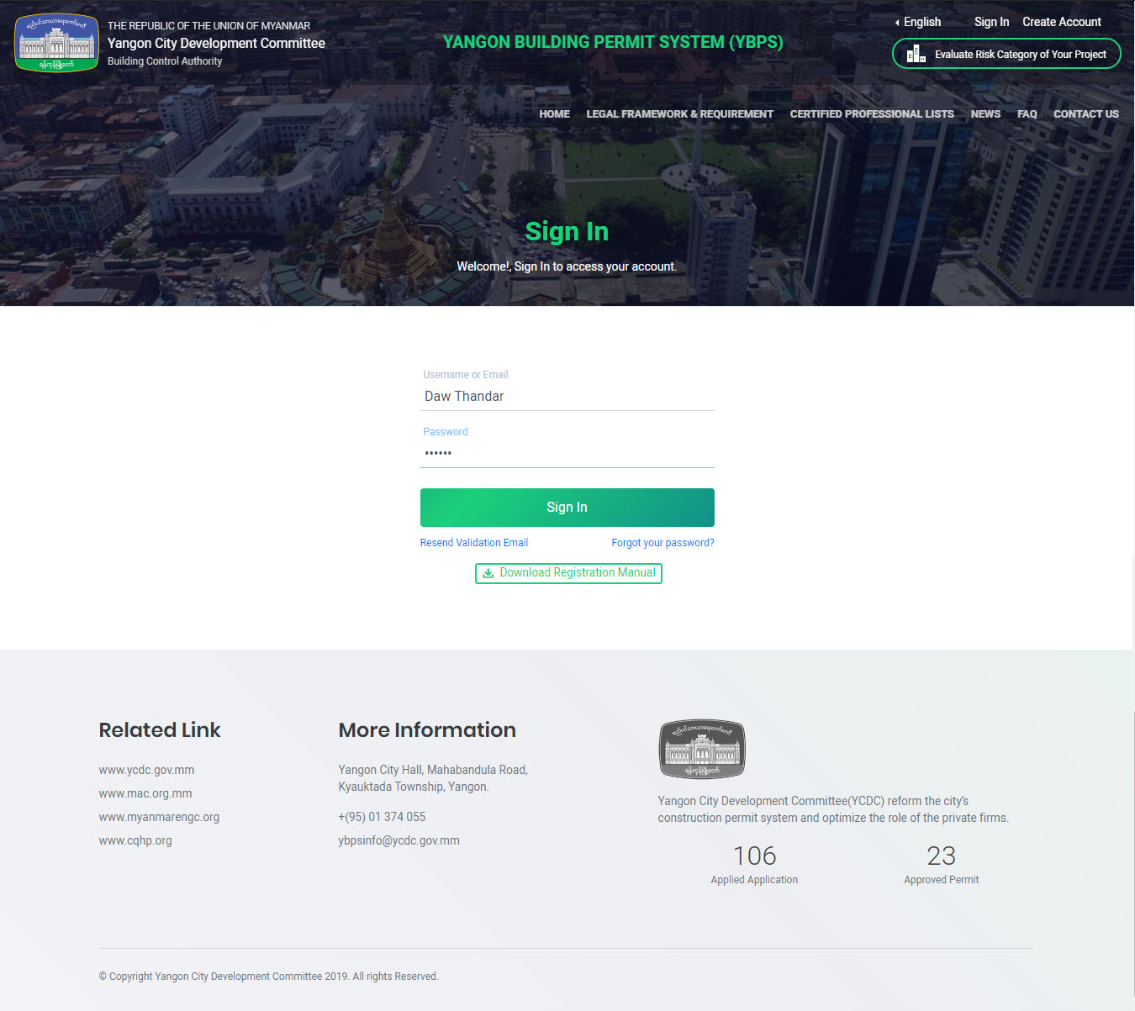
After fill out user name & password, click Sign In button.
Dashboard of the account will be shown as below. Click Make Application button, applicant can fill out the necessary document for license extension or new license.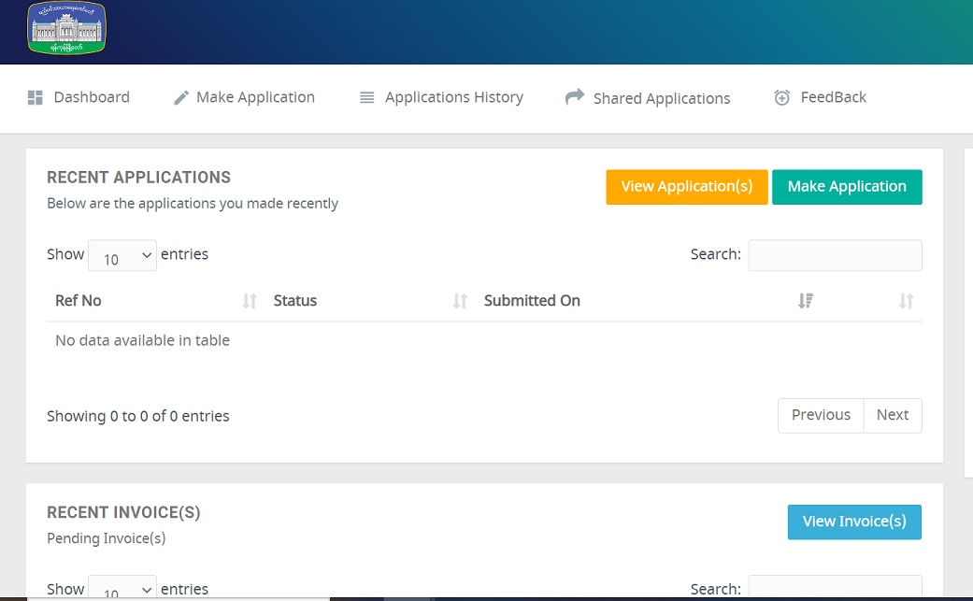

If your email address is not same with the one that had given to the Building department, please contact khinmyomyintwin.ycdc@gmail.com for the new gmail.

